DOWNTOWN HINESVILLE PARKING AREAS

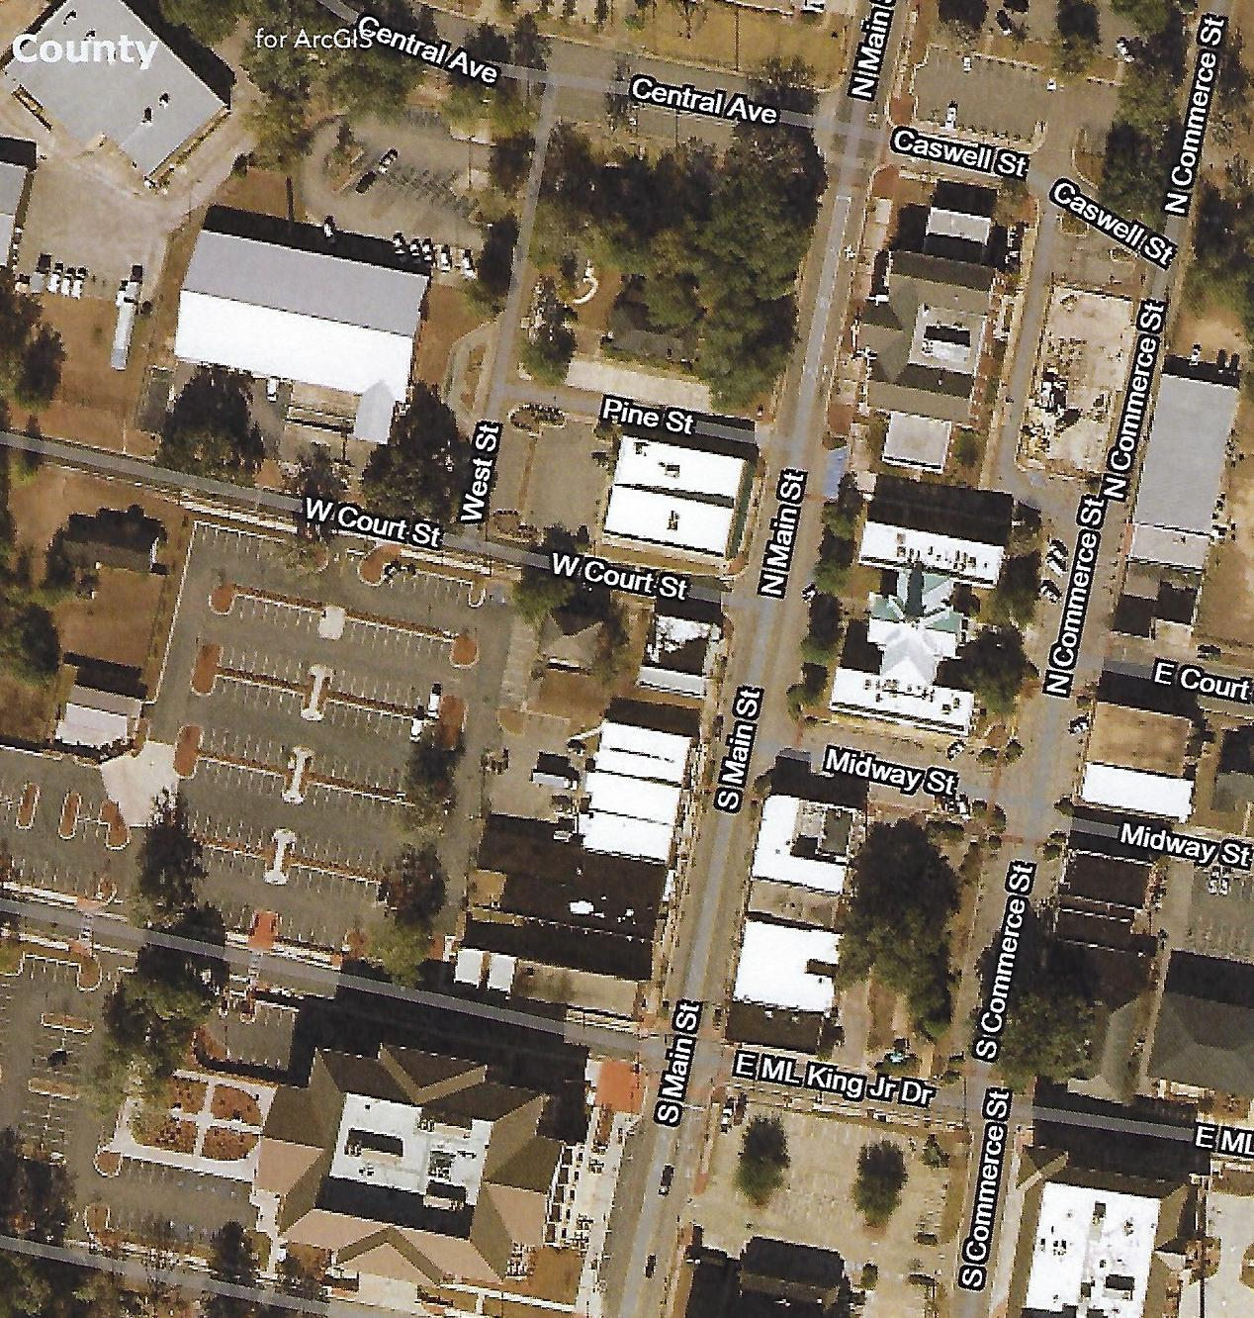
Courthouse

Areas outlined in Red or Public Parking Location
Easy Walk to Courthouse

